CUDA algorithm for parallel decoding of any LDPC Code using GPU
  - Abstract: This project provides a parallel approach of an iterative Low Density Parity Check (LDPC) decoder. CUDA offers parallel data computing using the highly multithreaded coprocessor driven by very high memory bandwidth GPU. The parallel decoding algorithm, based on CUDA, allows that all bit-nodes or check-nodes work simultaneously, thus provides an efficient and fast way for implementing the decoder.
Introduction: Robert Gallager invented LDPC codes in his PhD thesis. They are originally invented in the early 1960’s and have experienced an amazing comeback in the last few years. In today’s coding theory LDPC codes are one of the hottest topics. Unlike many other classes of codes LDPC codes are already equipped with very speed encoding and decoding algorithms. The question is that of the design of the codes such that these algorithms can recover the original code word in the face of large amounts of noise. New analytic and combinatorial tools like GPU etc. make it possible to solve the design problem. This makes LDPC codes not only attractive from a theoretical point of view, but also perfect for practical applications.
  - LDPC [Low Density Parity-Check] code:
LDPC codes are powerful error correcting codes adopted by recent Communication standards. LDPC codes are linear block codes which means every linear combination of code word is itself a code word, for example our message in binary strings. We divide our message in block of bits with length ‘k’. All the information can be represented in 2^{k} different messages.
u = (u₁, u₂, u₃ …….. u_{n})
We add ‘m’ non useful (noise) bits to our message ‘u’ it becomes new message ‘x’ represented by ‘n’ bits.
n - m = k;
n = x₀, x₁, x₂……….. x_{n-1};
= u0*g₀, u₁*g₁ ,…… u_{n-1}*g_{n-1}; as a linear codes also can be written as
x = u*g
G is a matrix with (k, n) dimensions. G is generator matrix.
There exists a matrix H (m, n) dimensions such that
GH^{T} =0 (0 is all zero matrix (k, m);
u*g*H^{T}=0;
x* H^{T} =0.
Matrix H is known as parity check matrix and scalar product with a code word x must be zero as shown above.
  - How to use this information?
At receiver if we know this parity check matrix ‘H’ upon receiving a n bit message we have to do a scalar product with H^{T}.
If don’t get a null matrix we can say that there is an error in our received message.
We can detect the error and correct it using many techniques based on properties of G and H matrices.
Communication process for transferring information to a noise channel
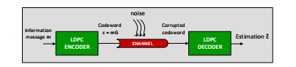
Utilization of the noisy channel for the Bit Error Rate simulation
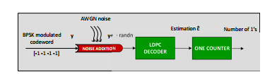

  - Why these are called low density codes?
Since the parity check matrix contains very less non zero matrix
Most of the matrix is sparse.
Basically there are two different possibilities to represent LDPC codes
- Matrix representation
- Graphical representation

  - Graphical representation:

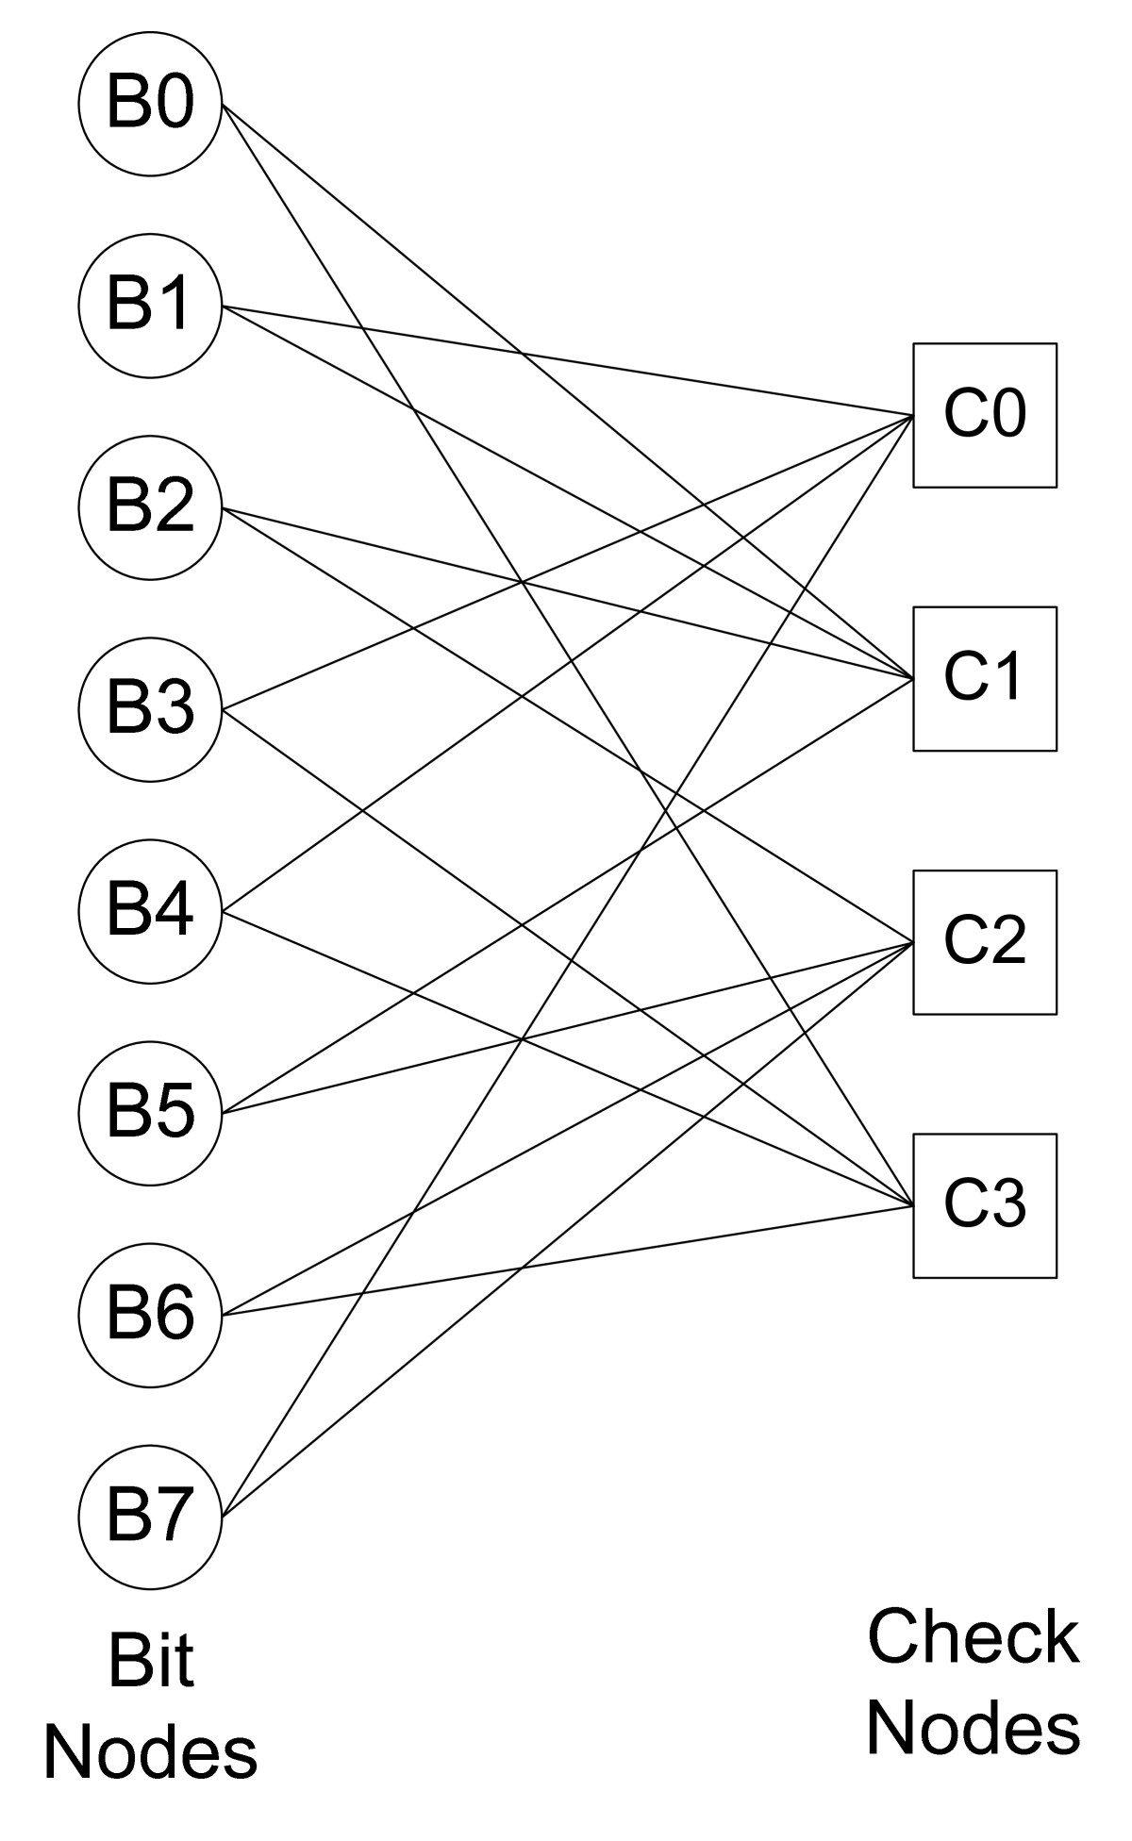

The above graph is a tanner graph. Tanner graph is an example for bipartite graph.
Circular nodes represent variable nodes and the square shaped nodes are Check nodes.
Degree of each node on the left is 2.
Degree of each node on the right is 4.

  - Matrix representation:
Let A (dv, dc) be LDPC code in which each row of H has dc 1’s and each column of H contains dv 1’s.
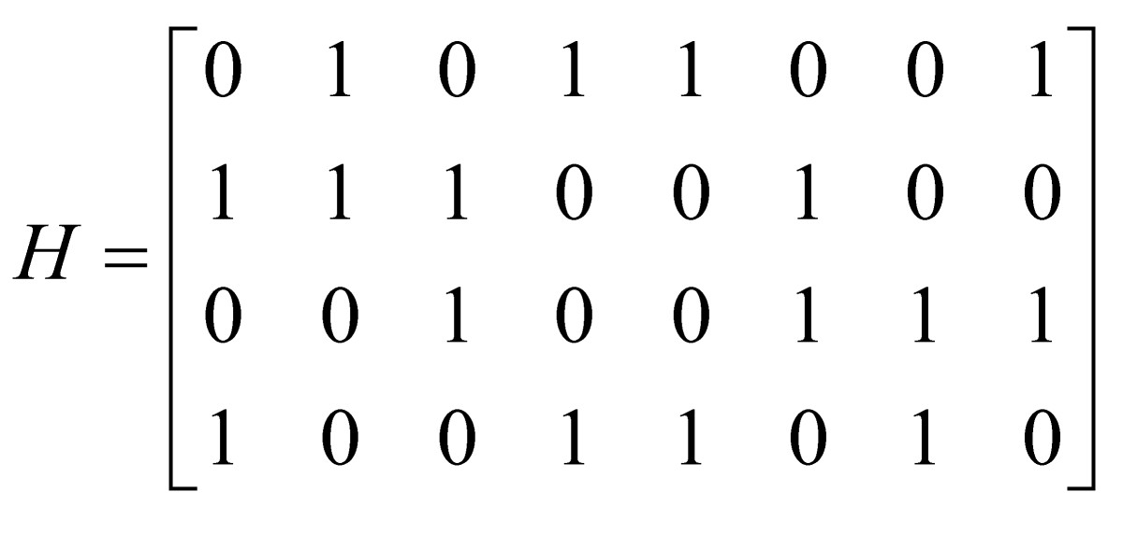
Every row has hamming weight 6.
Every column has a hamming weight 3.
LDPC code can be regular or irregular .The above parity check matrix is regular because the number of 1’s in each row are equal and the number of 1’s in each column are equal. This will be not the case when it comes to the irregular LDPC code.
  - Parallelization of LDPC decoding:
An LDPC decoding algorithm is capable of correcting errors by repeatedly computing and exchanging messages. The amount of computation depends on the size of the H-matrix. the length of code words is getting longer as the amount of data transfer is increasing. By the same way, the size of the H-matrix is increasing.
LDPC decoding consists of four general operations: initialization, check node update, bit node update, and parity check. The algorithm reveals that the check node update can be done in parallel, since the rows are uncorrelated with each other. Also, the bit node update on each column can be processed in parallel, because an LDPC decoding algorithm has independent memory accesses among the four types of operations. Check node operations can process four rows in parallel, and bit node operations can process eight columns concurrently.
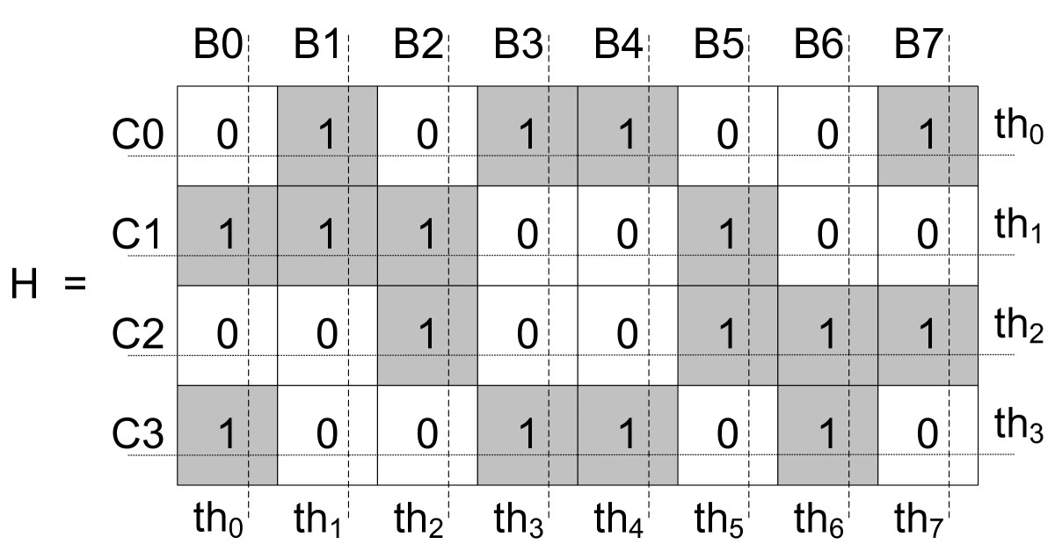
We propose parallelization techniques for not only check and bit node update operations, but also parity check operations.
  - CUDA programming:
CUDA is a GPU software development kit proposed by David Kirk and Mark Harris. One major advantage of CUDA is that it is an extension of the standard C programming language. CUDA is capable of fully utilizing the fast-improving GPU processing power.
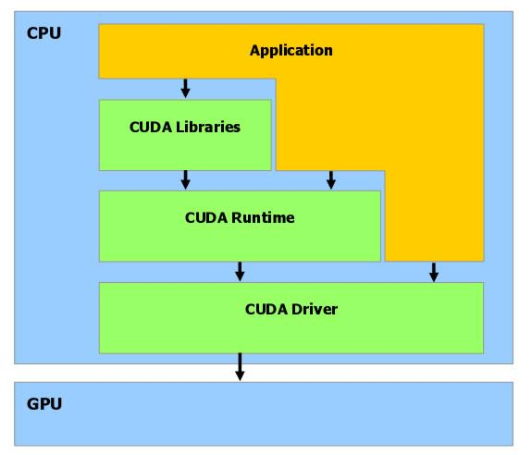
Fig : CUDA programming model

There are 16 multiprocessors, and each multiprocessor has 8 single precision thread processors (SPs). Each SP can process a block of data with a thread allocation in parallel. However, it is not possible for the CPU and the GPU to share memory space. If the CPU wants data stored in the memory of the GPU, a similar copy operation must take place.
  - Proposed LDPC decoder
When the size of H-matrices increases the amount of computation increases rapidly. This makes it difficult to achieve satisfactory performance in either software- or hardware-only implementations that attempt to support multiple standards and data rates. We propose a parallel software implementation of LDPC decoding algorithms that are based on CUDA programming.
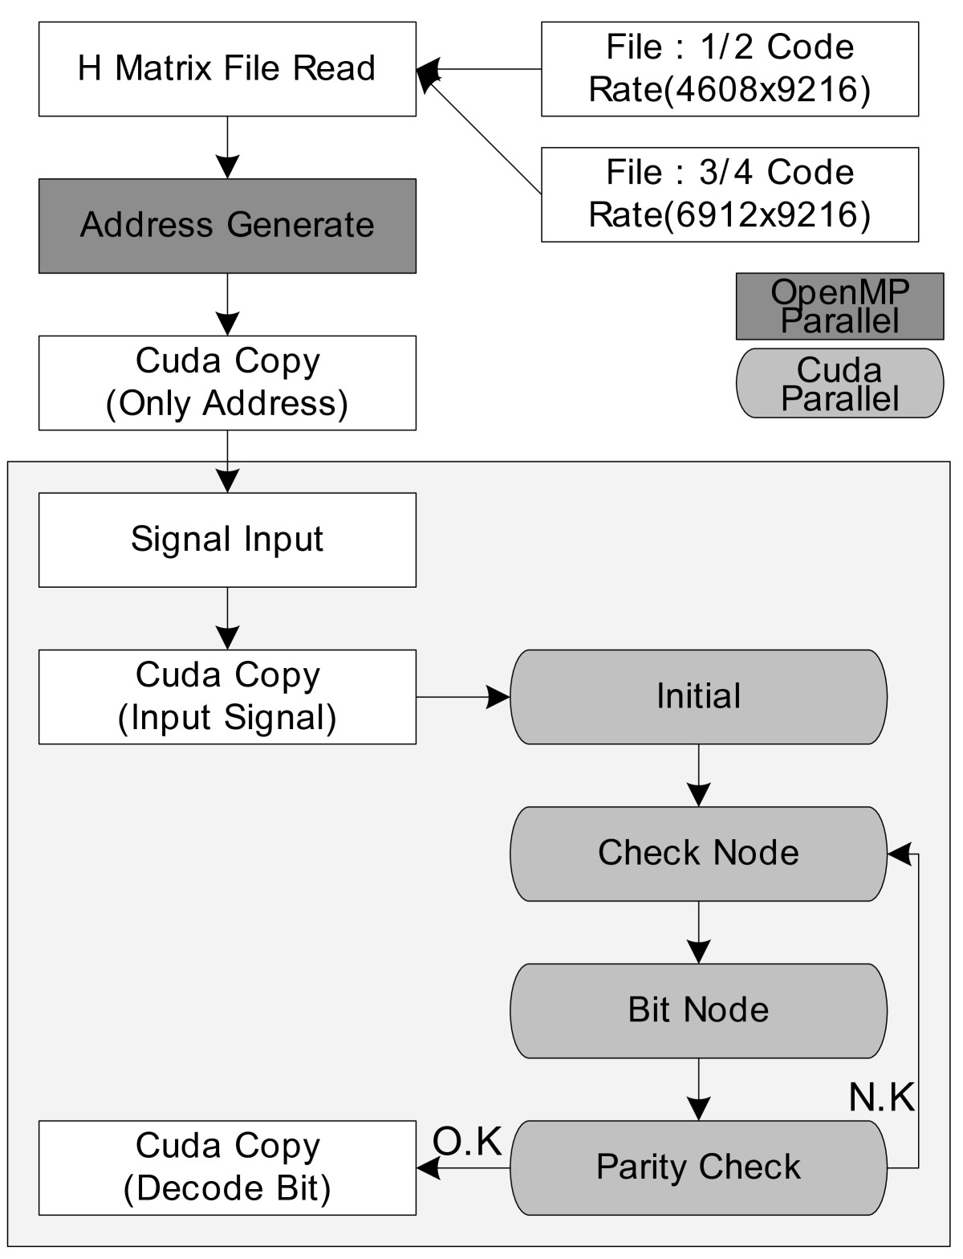

  - LDPC decoder using CUDA:
1. Host (runtime), running serially on CPU.
2. Kernel (device), running parallel on GPU.
In the following diagram we can see the workflow for decoding LDPC codes with CUDA, where the kernel modules means the program executed on GPU.
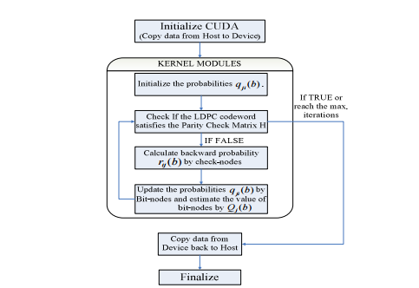
Fig. The workflow for decoding LDPC codes with CUDA, where the kernel modules means the program executed on GPU
The kernel is executed by the host. In CUDA, the kernel execution is more straightforward compared to OpenCL. Types used for code deﬁnition and passing messages are
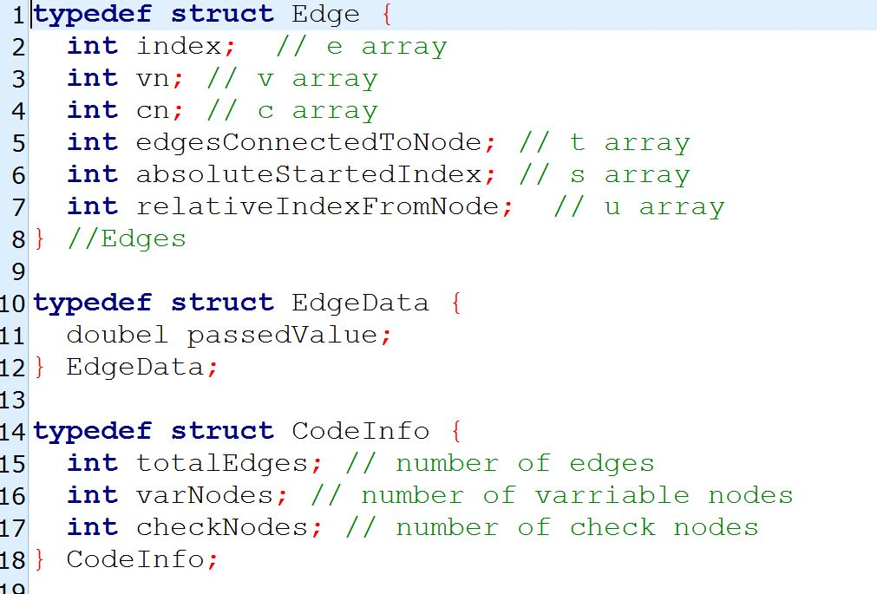

Execution of kernel function from run time:
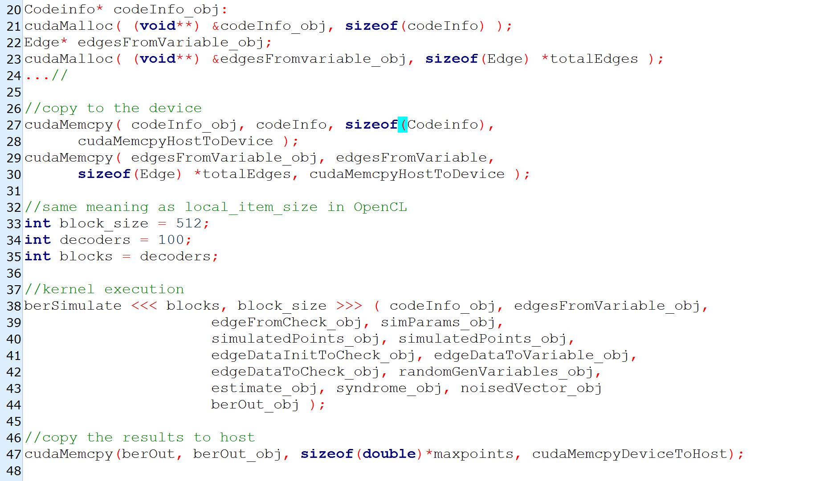
Decoder function runs from kernel:

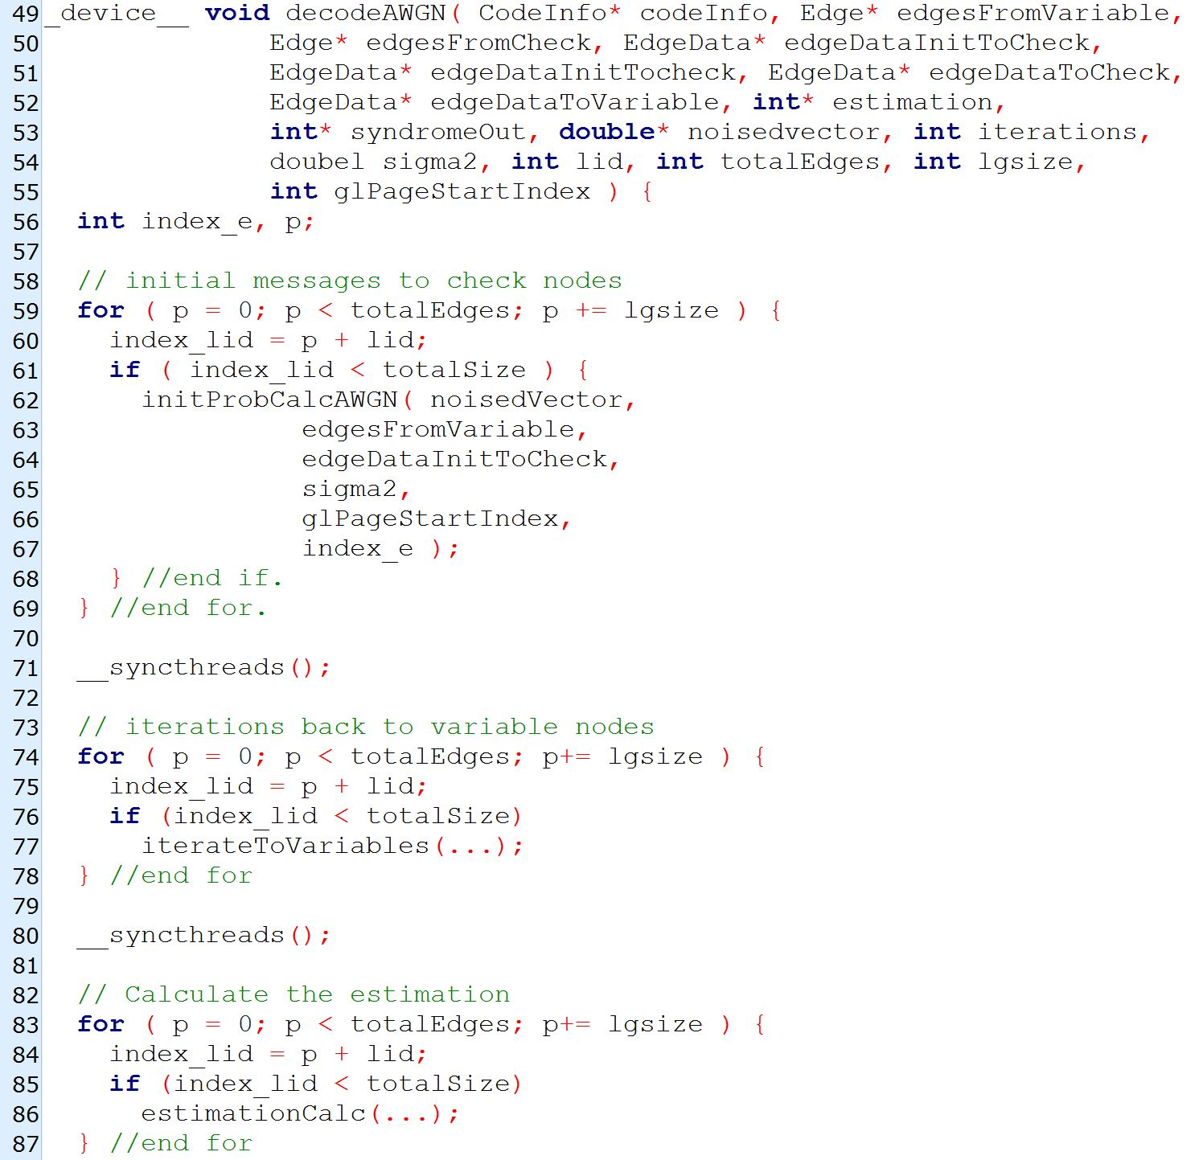

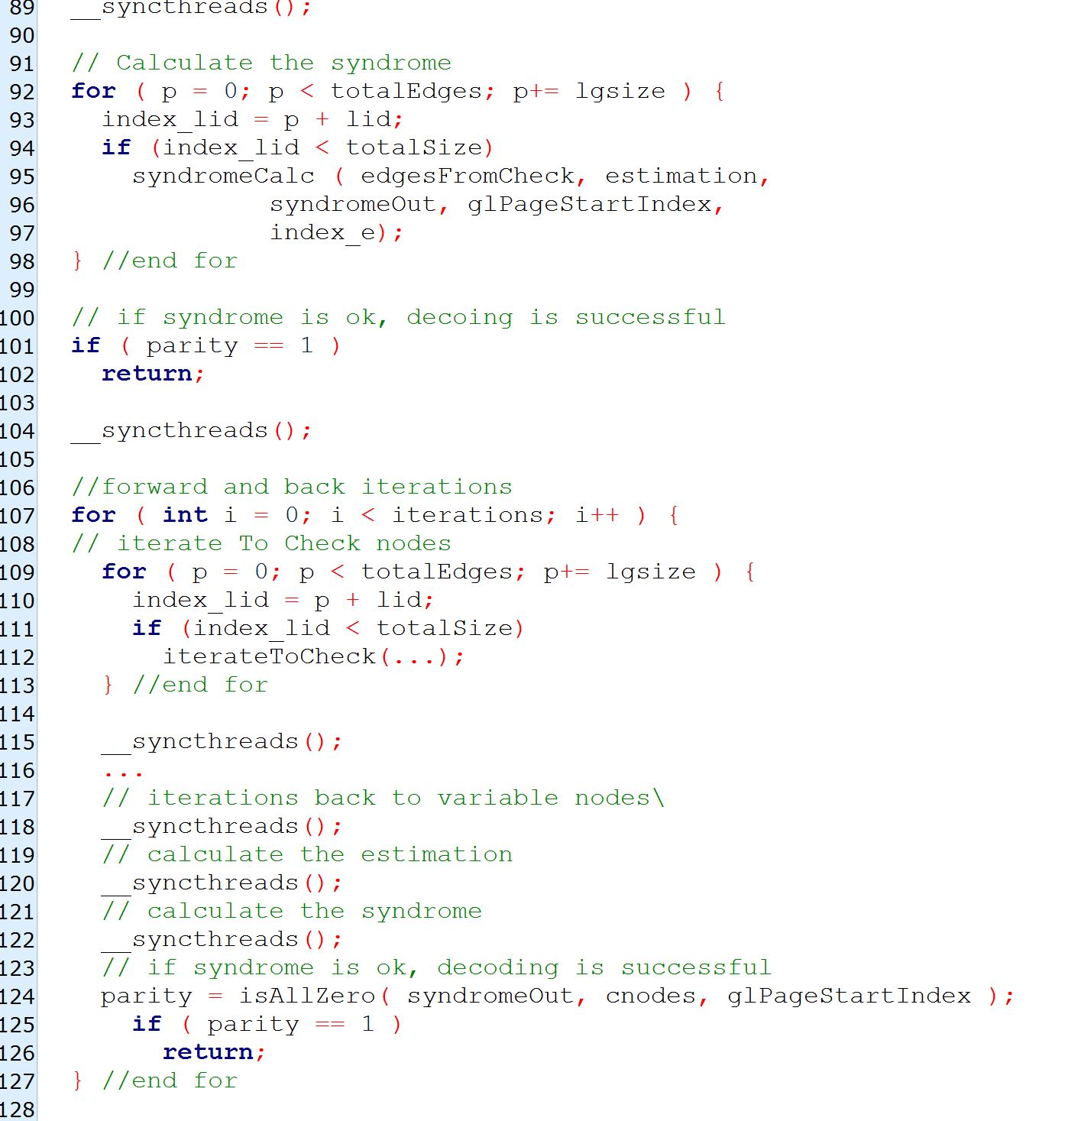

Now let us check how a basic LDPC code works on normal CPU we can see the Source code of it in below The actual code is
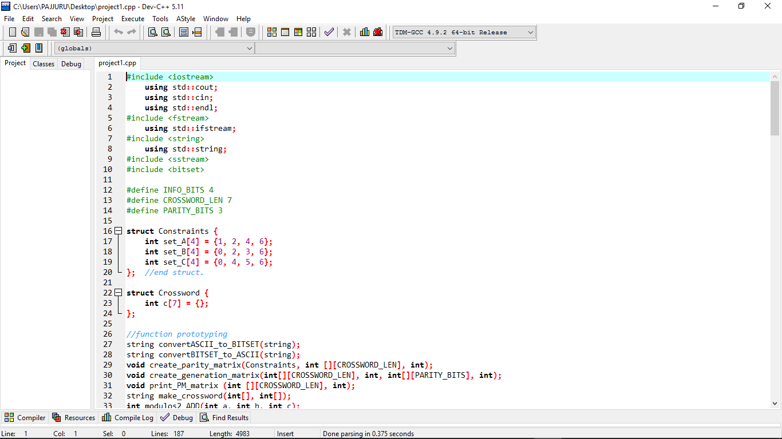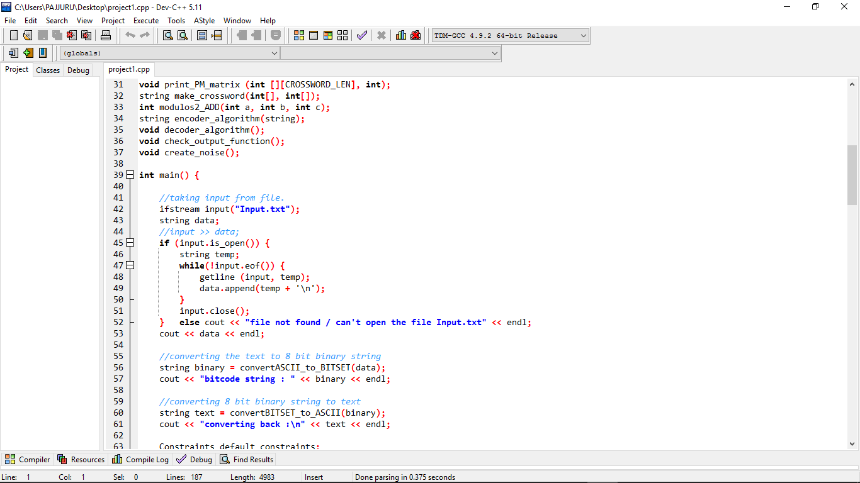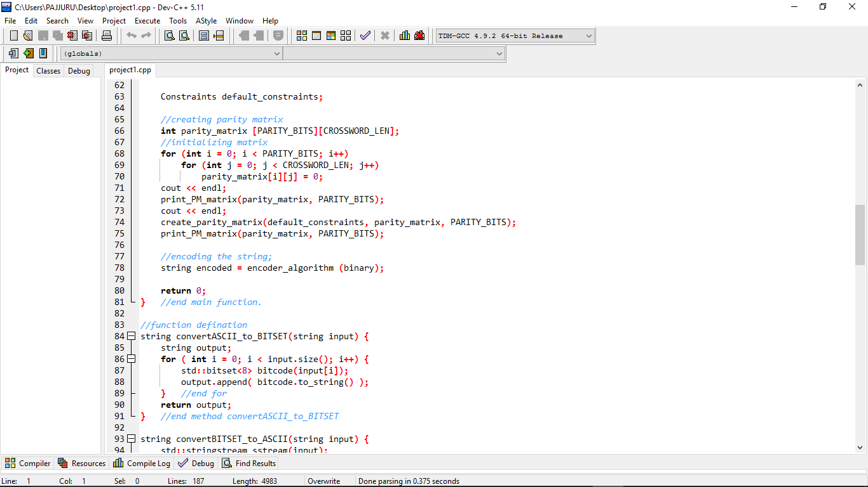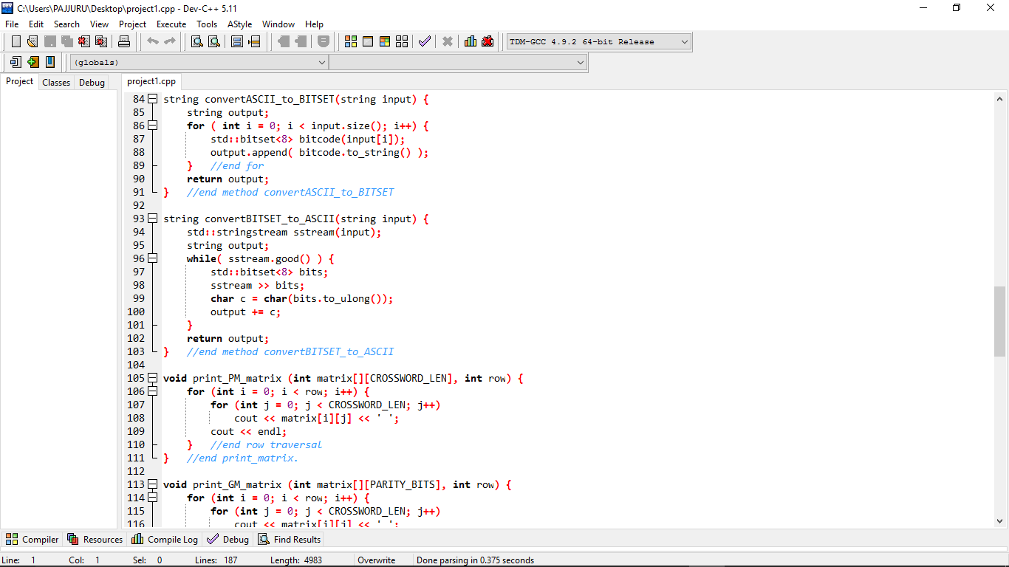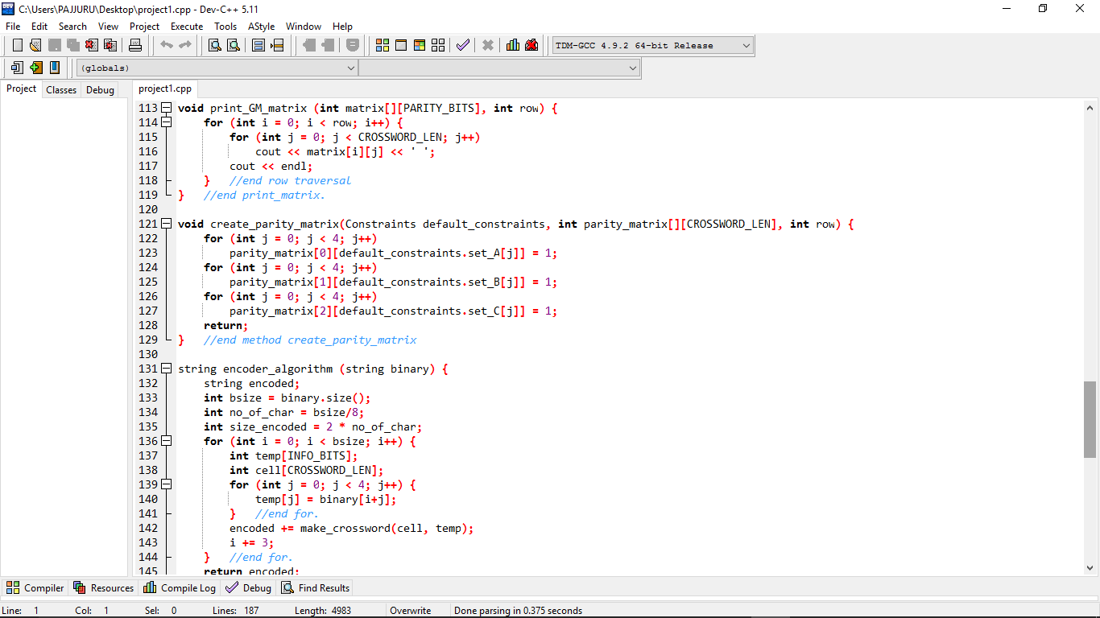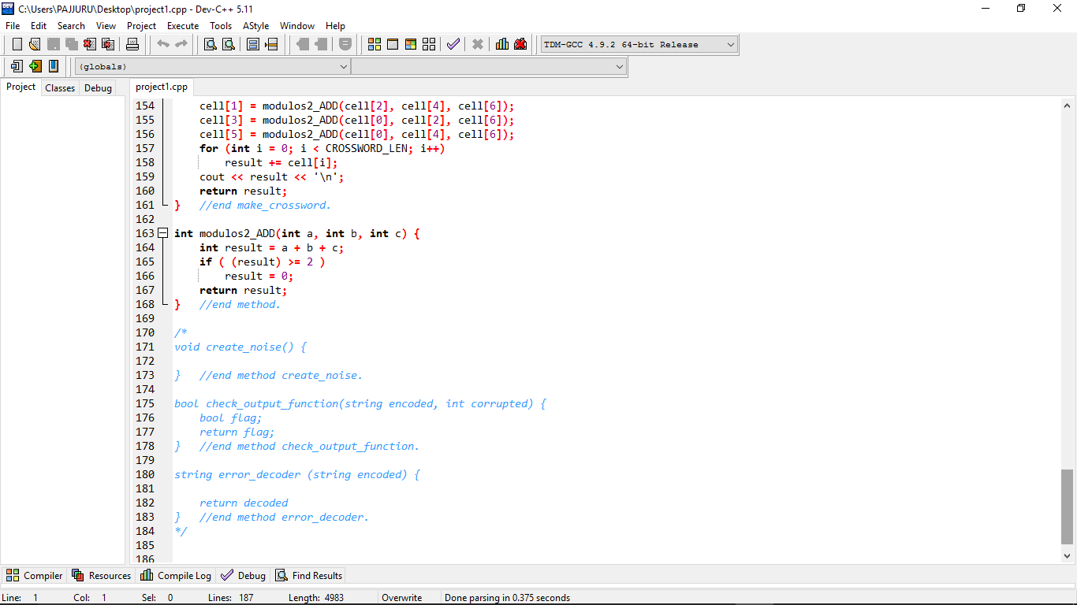
The Input text message for the above source code is
this is test
subject is not decided.

The output for the above program
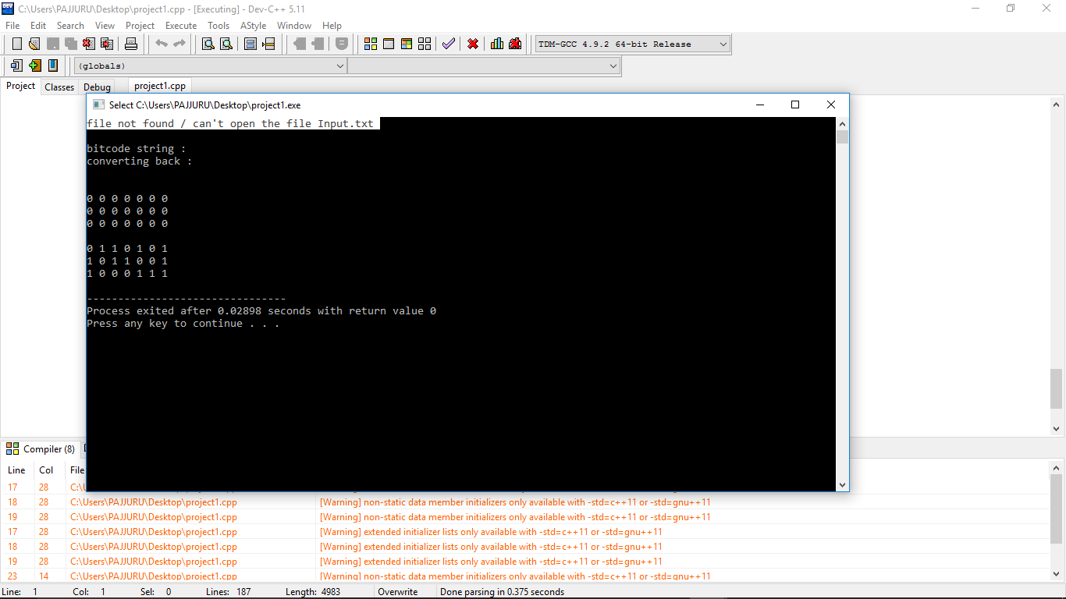

CUDA framework (local group of 512 threads and 100 decoders working in parallel) against the CPU implementation using C++ compiler with O3 optimization. Time was measured for 10000 decoded code words
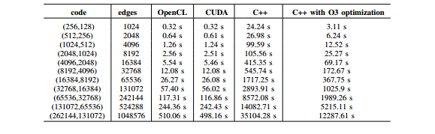
  - Conclusion: Low-density-parity-check codes have been studied a lot in the last years and huge progresses have been made in the understanding and ability to design iterative coding systems. We study these only because of the modern day technology.

  - References:

https://arxiv.org/pdf/1609.01567.pdf
http://www.bernh.net/media/download/papers/ldpc.pdf
http://wwwmayr.informatik.tu-muenchen.de/konferenzen/Jass05/courses/4/presentations/Janis%20Dingel-Low%20Density%20Parity%20Check%20Codes.pdf

Krishnamohan Pajjuru 50490270

Manideep Reddy Baddam 50491154

Srinivasula reddy Gopi reddy 50491704

